

Re-operate Lake Powell and Lake Mead for Ecosystem and Water Supply Benefits

Term Project

CEE 6410

Course Instruction: Dr. David Rosenberg

Submission Date: 13-12-2020

Authors: Moazzam Ali Rind, Mahmudur Rahman Aveek

# **Abstract**

The endemic fish population, especially the humpback chub (HBC), has been resurgent within the Grand Canyon reach of the Colorado River. Recent studies have attributed this population boom to prolonged drought; one leading theory suggesting that the release temperature has increased as the shortage caused a significant water elevation reduction at the Glen Canyon Dam. Also, as the Lake Mead elevation dropped over time due to this shortage, a rapid known as the Pearce Ferry Rapid was created at river marker 281.5, hindering the predatory fishes' encroachment on Grand Canyon Reach. While these natural phenomena have positively influenced the ecosystem, there are supply challenges that are inversely affected by the drought. The delivery requirements mandated by the Colorado River Compact of 1922 by both upper and lower basins have been hindered due to this decade long drought, which leads to the research question, whether it is possible to supply the mandated amount while addressing the fish ecology issue. We have used the multi-criteria decision-making approach to model different hypothetical dam operation scenarios to answer this question. Primary results suggest that over a short period of time both the water supply and ecosystem objectives can be achieved together. Whereas as due to variable inflows to the system over longer period, both objectives (water supply and ecosystem) competes amongst each other. Finally, the current model needs some modifications (e.g. monthly and annual volume constraints) to produce practical results.

# **Introduction**

The Colorado River's portion between Lake Powell and Lake Mead, known as the Grand Canyon (Figure 1), has a unique ecosystem and home to many endemic species for ages. For example, humpback chub (HBC), razorback sucker, bluehead sucker, flannel mouth sucker, and speckled dace are fish species native to Grand Canyon (National Park Service, 2014). The construction of Glen Canyon Dam (GCD) in 1963 has disturbed the natural physical and environmental processes of the Grand Canyon (Wright et al., 2009, Schmidt et al., 1998), which in turn has drastically affected the growth of native species. Some of the significant impacts are the change in temperature, which fluctuated wildly from the pre-dam period to a relatively cold and steady temperature, increased water clarity, reduced nutrient, changed flow pattern, and reduced sediment load (Gloss et al., 2005), hydropeaking, etc. There has been a recent resurgence since the elevation at GCD has dropped during early 2000 due to drought. Especially, the HBC population has increased within the Grand Canyon reach, which was usually confined within the Little Colorado River, a tributary of the Colorado River (Rogowski et al., 2018). The drought that started in early 2000 is somewhat responsible for this population boom, as the elevation of Lake Powell decreased, the release temperature of the water increased. Also, the tributaries brought in warm inflows during summer months, coupled with the local climate of the Grand Canyon, have provided a suitable temperature (14-200 c) for spawning.

Moreover, a decrease in Lake Mead's elevation created the Pearce Ferry rapid at RM 281.5, which prevented non-native predatory species from swimming upstream. While Colorado River Compact of 1922 and Water Treaty of 1944 ensures the Upper basin and Lower basin water requirement which are 8.23 MAF/year, and 9.0MAF/year (USBR), respectively, the reduced river flow has proved to be of great importance for native fauna.

The multi-criteria decision-making approach is used to investigate the issue. The goal of this study is to find a suitable dam operation scenario that can maximize the both the water supply and ecological objectives. The report provides the findings from the recent studies, briefly discuss current dam operation, give a detailed description of the model formulation, the assumption made for the model, and the successive sections.

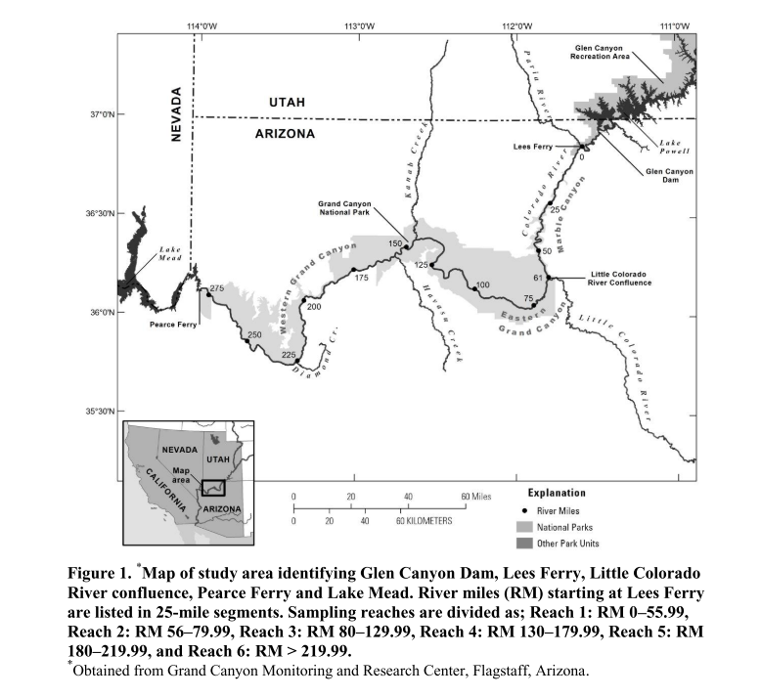

Figure 1: Different reaches of the Colorado River at Grand Canyon (Bunch et. al., 2012)

# **Literature Review**

Most fish species native to the Colorado River are acclimatized to temperature fluctuation (from 0°C to 27°C during the pre-dam period). Still, spawning occurs during the summer months when the temperature exceeds a certain threshold (Gloss et al., 2005). For instance, humpback chub, an endangered fish species, require summer water temperatures between 14 to 20 °C to spawn (Valdez et al., 2013). Its most tremendous egg hatching success occurs at 20°C (U.S. Fish and Wildlife Service). Before the Glen Canyon Dam construction, the Grand Canyon's water temperature was highly variable, with icy spring run-off to the warm 29.4°C summer flows (Glen Canyon Dam Wiki, 2020). However, after Glen Canyon Dam's operation, the river turned into a cold, monotonous stream (Figure 2). As a result, the late-twentieth-century studies found that the population of HBC was restricted to the Litter Colorado River and nearby areas in the mainstem Colorado River only (Glen Canyon Dam Wiki, 2020 and Rogowski et al., 2018). However, recent surveys indicate a resurgence of the HBC population near the Grand Canyon's western region. Researchers have determined that the Western Grand Canyon HBC is relatively young and hypothesized that the revival happened after 2000 (Rogowski et al., 2018). Specifically, there are speculations that Lake Powell was at its lowest in 2005, and it was releasing warm water (15 °C) comparatively that would have helped the growth of the HBC (Voichick et al., 2007). Likewise, evidence shows the population increase of other native fish populations, i.e., Bluehead Sucker, Flannel mouth Sucker, and Speckled Dace in recent years (Kegerries et al., 2020).

Besides stream temperature, several possible reasons are attributed to this revival of the native fish population in the Grand Canyon. For instance, creation of a natural barrier called Pearce Ferry Rapid that obstructs the upstream movement of non-native fishes from Lake Mead (Kegerries et al., 2020), Trout management flows between 2003-05 that controlled the non-native trout fish population by destroying trout eggs (USGS 2011) and High Flow experiments (HFE) which helped: rate of sediments transport, development of sand bars, removal of non-native vegetation, and growth rate of native flora and fauna (Rice 2012). At present, to increase river food web in the Grand Canyon, bug flow experiments are in practice since summer 2018. The idea behind the bug flow experiment is to provide steady low flows on the weekend for invertebrates to lay and hatch eggs (Kennedy et al., 2016). Since it is an on-going experiment, therefore, the eco-system benefits from the investigation are inconclusive, but hydropower benefits from the experiment are encouraging.

Another recent study (under review) attributed the rise in river temperature to GCD releases, especially within the first 141 kilometers from the GCD; for the rest of the region, the increase in temperature is attributed to a combination of discharge, short water radiation, and local air temperature (Mihalevich et al., 2020). It is uncertain how raising the temperature will affect the native and non-native ecosystems. Rosenberg, D. (2020) suggests that a release from the elevations between 3,600 and 3,675 feet MSL from the GCD during August to October will keep the release temperature below 150 c, which is suitable for most of the endemic fishes except for razorback sucker. Moreover, releasing from an elevation below 3,600 feet will increase the temperature significantly. The consequence of such temperature increment on the native fishes is uncertain as the increased temperature will also favor the non-native fishes such as channel catfish, common carp, fathead minnows (National Park Service, 2018). The recent target elevation was set at 3,525 by the contingency plan for upper basins (USBR, 2019). While such management action may provide security to the upper basin’s scarcity problem, it may harm the native species.

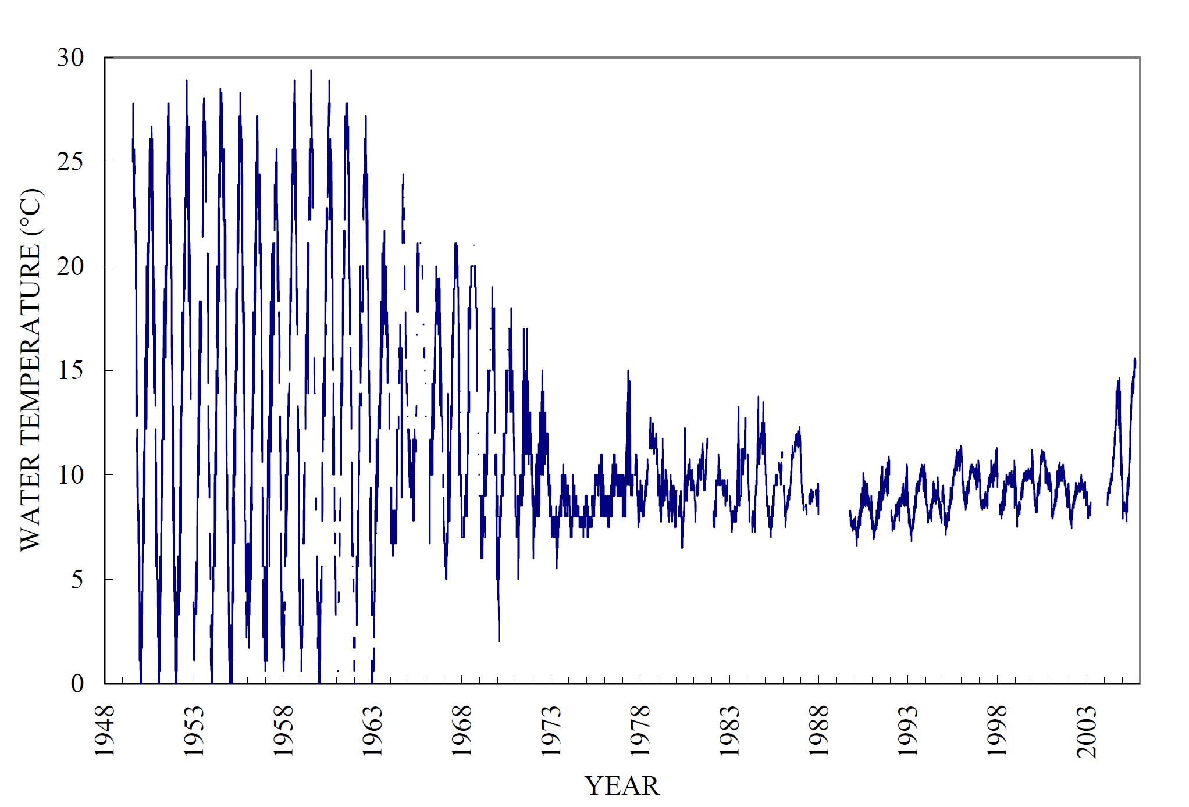

Figure 2: Daily water temperature measured or calculated at Lees Ferry gauge (station id 09380000) (Voichick et. al., 2007)

Geographically, the Colorado River passes through seven western states (i.e., Arizona, California, Colorado, Nevada, New Mexico, Utah, and Wyoming) of the U.S and drains into the ocean in Mexico. The equitable allocation and distribution of Colorado River water among the stakeholders are ensured through the Colorado River compact of 1922 (USBRa). The compact divided the states into two basins; the Upper basin states are Colorado, Utah, Wyoming, and New Mexico, while Nevada, Arizona, and California were enlisted as the Lower basin states. Although Mexico was recognized as a shareholder of the Colorado River in the 1922 compact, its share was not decided until the Mexican water treaty of 1944 (USBRb). Article III of Colorado River compact,1922 allocates an equal amount of stake to both the basins, i.e., 7,500,000, acre-feet of water per annum. It also enforces that the upper basin states will not cause the flow of the river at Lee Ferry to be depleted below an aggregate of 75,000,000 acre-feet for any period of ten consecutive years. Also, the Colorado River compact in various of its articles allows the development of storage facilities, water supply networks, and hydropower generation plants to get the maximum benefit from the apportioned water. For instance, Hoover Dam was built in the lower basin in 1936 to control floods, ensure continuous water supply, and produce hydropower. Likewise, Glen Canyon Dam was completed in 1966, and its main reason was to safeguard lower basin water share and produce hydropower. In the 1922 compact, the allocation to Mexico will be upheld by any basin in surplus, or both basins will contribute equally.

Although, the GCD is usually operated between an elevation range of 3,490 (minimum power-pool) and 3,700-feet MLS, water can be release from an elevation of 3,370 ft via river bypass (USBR, 2007). The Lake Mead can store up to an elevation of 1,229 feet and release can fluctuate from 1,000 to 49,000 cubic feet per second (USBR, 2000). For the model formulation of this study, these parameters were used as physical/ operational constraints. This study will not delve into the ecology part of the Grand Canyon reach and consider that a release temperature between 12-15oc will benefit the endemic fish population, while admitting that such release temperature may also help the non-native species to spawn. The study will use the temperature range provided by Rosenberg, D. (2020) (Figure 4), which is 3,600 to 3,675 between summer months, to formulate the model’s release objective for summer months. This study is aimed to build a systems model for the Grand Canyon Reach of the Colorado River considering water supply, and eco-system objectives. The presented work will explore possible operational schemes for both reservoirs under different volumetric and ecological scenarios. The developed model will be helpful to quantify trade-off between ecosystem and Upper and Lower Basin water requirement objectives. So, the model will also try to incorporate the developed reservoir elevation and downstream temperature relationships for Lake Powell (e.g., Figure 3) in order to provide favorable conditions for native fishes.

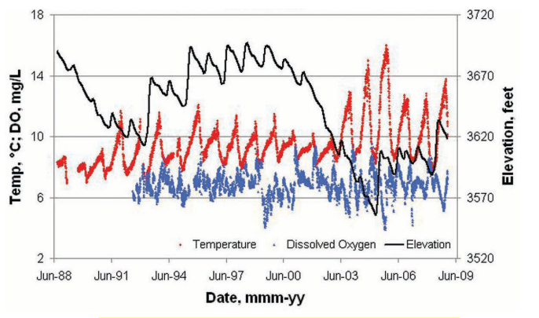

Figure 3 Daily water temperature and dissolved oxygen concentration below Glen Canyon Dam with Lake Powell water- surface elevations, 1988–2008 (Williams, 2009)

# **Data Collection**

Most of the data were collected from USBR and the United States of Geological Survey’s (USGS) website. The storage capacity data at different elevation for Lake Mead and Lake Powell were collected from Colorado River Simulation System (CRSS). Also, the evaporation was calculated as a function of live storage (which is a function of surface area) and was also generated from the rates provided in CRSS. All the data, used for the model can be found at: <https://github.com/moazzamalirind/Rind/tree/master/Class%20project>

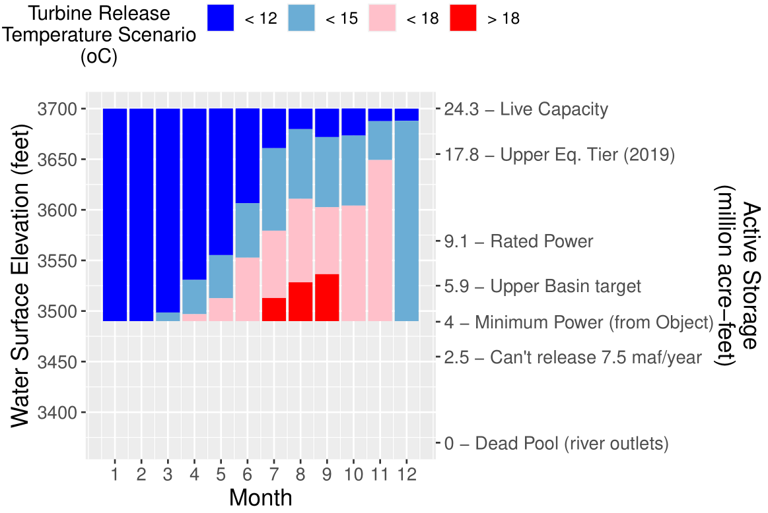

Figure 4: The elevation and release temperature range from the Glen Canyon Dam for different months (Rosenberg, D. 2020)

# **Model Formulation**

The Model was developed to optimize the coordinated operation of Glen Canyon Dam and Hoover Dam. Both the dams are currently operated for different objectives (e.g. hydropower, downstream sediment transport etc.), however, we have considered four management objectives: 1) Maintain favorable elevation of Lake Powell, the release temperature during summer months (i.e. May to August) remains 12 to 15 °C. 2) Meet annual upper basin delivery of 8.23 MAF to lower basin states i.e. releases from Glen Canyon Dam + Paria River inflows (Colorado River Governance Initiative, 2012). 3) Maintain elevation of Lake Mead below 1135 ft. to keep the Pearce Ferry Rapid intact. 4) Meet annual lower basin water supply demand of 9 MAF from Lake Mead. The model made decisions about storage and releases at both the reservoirs (i.e. Lake Powell and Lake Mead) and was subjected to reservoir physical constraints (i.e. minimum and maximum storage and release capacities), reservoir mass balance, and end of the simulation period storage constraint.

The model works on a monthly time scale, because the operations (specifically release hydrograph) at the selected reservoirs are decided at the monthly timestep. Besides, selection of monthly time scale helped increase the horizon of the study period, while saving some of the specifics of the system. For example, release temperature during the summer months is a function of monthly storage level, the amount of water evaporated being function of surface area and month of the year etc.

## **Model Dimensions**

` The model considers two dimensions throughout its calculations: time and space (location). Here, the units of time will be months and years, and the location will be either Lake Powell or Lake Mead. All the storage values in the model has unit of acre-ft and the releases being made in cfs.

## **Objective Functions**

The four management objectives considered in the model:

1. Maximize the number of summer months when the elevation at Lake Powell is in-between 3600 to 3675 ft. Within these two elevation levels, the reservoir release temperature is expected to be in-between 12 to 15 °C.

∑year ∑Month (Increasing sigmoidal function* decreasing sigmoidal function ) ∀ years, summer months only (i.e. M8 to M11 of WY calendar) ..(1)

## **Sigmoidal Function**

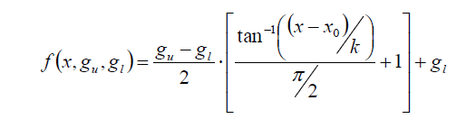To quantify the suitability of the objective functions, we have used the sigmoidal function given by Alminagorta et. al, (2016). That function is developed by exploiting the arctangent function and has been adjusted as per study objectives. For instance, equation 2 provides the basic sigmoidal function given in Alminagorta et. al, (2016) paper.

.. (2)

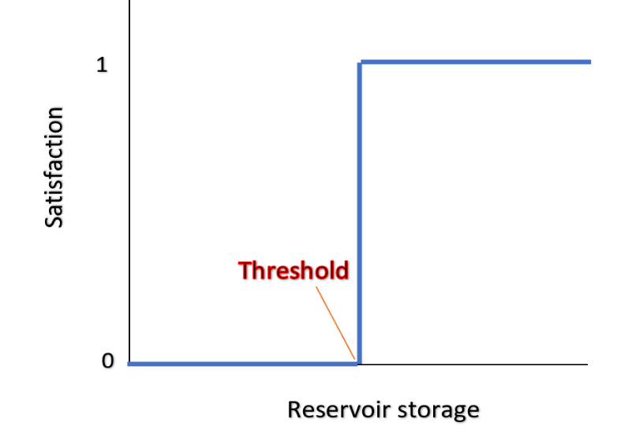Here, X is the variable, K is the slope of the curve between 0 and 1, Xo is the threshold, gu is the upper limit of the function and gl is the lower limit of the function. There are two types of sigmoidal functions: Increasing and decreasing sigmoidal functions. Equation 2 is for increasing sigmoidal function and its visualization is presented in Figure 5.

Figure 5 Typical Increasing Sigmoidal function

It can be seen in Figure 5 that sigmoidal function is a continuous function which extends between 0 (no satisfaction) to 1 (complete satisfaction). This switch from zero to 1 happens around the threshold value of the objective. For example, annual release of 8.23 MAF from the reservoir can be a threshold. Moreover, the slope of curve during switch from 0 to 1 can be controlled by adjusting the value of K in equation 2. For this study, we found value of K=0.01 most suitable.

For example, Figure 6 shows the sigmoidal function we have used for our first objective (i.e. temperature objective of Glen Canyon dam). Here, we have multiplied both increasing (blue cure) and decreasing (orange curve) sigmoidal curves to count only the feasible in-between region.

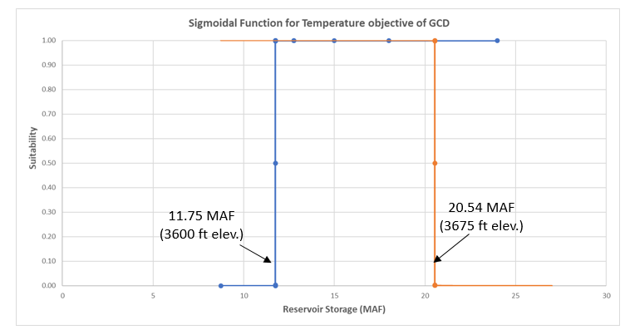

Figure 6 Sigmoidal Function used for the GCD temperature objective.

1. Maximize number of years the upper basin delivers 8.23 MAF or more to the lower basin states. The amount of flow counted will be sum of releases from the Glen Canyon Dam and inflows from the Paria River. Sigmoidal function was used to quantify the objective function value.
2. Maximize number of months when Lake Mead has elevation below 1135 ft. to keep the Pearce Ferry Rapid intact. Same sigmoidal function was used to represent and quantify the objective function value.
3. Maximize number of years Lake Mead can meet the annual water supply target of 9 MAF.

Sigmoidal function was used for this objective as well.

## **Decision Variables**

Two decision variables are involved in the Model:

1) Releases from the reservoirs (cfs).

2) The end of the month reservoir storage in Lake Powell and Lake Mead (ac-ft).

## **Constraints**

For the base model, there were reservoir physical constraints (i.e. minimum and maximum storage and release capacities), reservoir mass balance, and end of the simulation period storage constraint.

However, we introduced some additional constraints to test the application of model for scenarios. For example, the monthly release volume proportion used by Western Area Power Administration (WAPA) in their monthly allocation Glen Canyon Dam model.

1. **Maximum Storage Capacity of the Reservoirs (ac-ft)**

Storage (Loc, yr, M) < MaxStorage (Loc)

∀ Loc ∈ Location, yr ∈ Year and M ∈ Month ..(3)

1. **Minimum Storage of the Reservoirs (ac-ft)**

Storage (Loc, yr, M) > MinStorage (Loc)

∀ Loc ∈ Location, yr ∈ Year and M ∈ Month .. (4)

1. **Maximum Outflow Capacity (cfs)**

This constraint restricts outflow from the reservoirs to be less than or equal to the maximum outflow capacity of the hydropower outlets, and bypass tunnels.

Release (Loc, yr, M) < MaxRel (Loc)

∀ Loc ∈ Location, yr ∈ Year and M ∈ Month ..(5)

1. **Baseflow Requirement (cfs)**

This equation ensures that the minimum release during anytime from any of the reservoirs should not go below the mentioned baseflow release.

Release (Loc, yr, M) > MinRel (Loc)

∀ Loc ∈ Location, yr ∈ Year and M ∈ Month .. (6)

1. **Reservoir Mass Balance (ac-ft)**

The mass balance was applied to both the reservoirs separately.

**At Lake Powell**

1. For the first timestep (i.e. yr =1 and M = 1).

Storage (Loc, yr, M) = initial storage + Inflow_Powell (yr, M) – Release (Loc, yr, m) * Convert * Yr_Month_Day(yr,M) – evaporation .. (7)

Where, Convert is the factor (1.983) used to translate the cfs into ac-ft/day and the parameter Yr_Month_Day tells the number of days in a month during a specific year.

For the evaporation, we analyzed the past 20-year data for each of the months and found two types of relationships fitting the data between reservoir storage and the evaporation volume. The first equation (eq a) works for months from M2 to M8 (i.e. November to June) and the second equation (eq b) works for remaining months (July to October).

Evaporation (ac-ft) = 0.0029 * Storage (Loc,yr,M) + 7200.6 (a)

Evaporation (ac-ft) = 0.0057 * Storage (Loc,yr,M) + 14360 (b)

1. For the timestep greater than one (i.e. yr=yr and M >1)

Storage (Loc, yr, M) = Storage (Loc, yr, M-1) + Inflow_Powell (yr, M) – Release (Loc, yr, m) * Convert * Yr_Month_Day(yr,M) – evaporation + Storage(Loc,yr-1,"M12")$(ord(yr)gt 1 and ord (M) eq 1) ..(8)

Here, the last term will take care of switch between the years. That is, at the start of next year (ord (yr) gt 1) consider the end storage of last year (i.e. yr-1 and M12) as the available storage to work with. The $ sign used here is just a typical coding script in General Algebraic Modeling System (GAMS) to control the applicability of the equation or a term.

**At Lake Mead**

1. For the first timestep (i.e. yr =1 and M = 1).

Storage (Loc, yr, M) = initial storage + Release (“Powell”,yr,m) + Inflow_Paria (yr,M) + Inflow_Local (yr,M) – Release (Loc, yr, m) * Convert * Yr_Month_Day(yr,M) –evaporation   
 .. (9)

Here, Inflow_ Paria is the monthly inflows from the Paria River in Ac-ft, and Inflow_Local adds all the monthly inflows from different tributaries (e.g. the Little Colorado River, Diamond creek, Havasu creek, and Kanab creek).

For the evaporation at Lake Mead, equation c works for months from M3 to M8 (i.e. December to June) and the second equation (eq d) works for remaining months (July to November).

Evaporation (ac-ft) = 0.0024 * Storage (Loc,yr,M) + 12046 (c)

Evaporation (ac-ft) = 0.0048 * Storage (Loc,yr,M) + 24010 (d)

1. For the timestep greater than one (i.e. yr=yr and M >1)

Storage (Loc, yr, M) = Storage (Loc, yr, M-1) Release (“Powell”,yr,m) + Inflow_Paria (yr,M) + Inflow_Local (yr,M) – Release (Loc, yr, m) * Convert * Yr_Month_Day(yr,M) - evaporation + Storage(Loc,yr-1,"M12")$(ord(yr)gt 1 and ord (M) eq 1) ..(10)

## **Additional Constraints**

1. **End of the simulation period Storage (Ac-ft)**

Storage (Loc,"y3","M12") > Init_Storage(Loc) (11)

This equation is only feasible if the model is run for few years of time (e.g. eq 11 is written for 3 years model) or there is more kind of consistent inflows during the long simulation period. For instance, the equation was found infeasible when applied to the extended 20-year model starting from 2000. At the start of 2000, the reservoirs were almost 75~80% filled and the following decade was a drought. Which means the deliveries were made from the available storages and there was no way that reservoirs can maintain the same initial storage level at the end of 20 years simulation period.

1. **Monthly release volume distribution suggested by WAPA**

In the Monthly allocation model for Glen Canyon dam developed and provided by WAPA, they have proposed a release of 2 MAF almost equally distributed during first three months of the water year and remaining annual release volume distributed in the following months.

We applied the same concept at Lake Mead but with 3 MAF release during first three months.

1. **Constraining the annual release volume**

The model was utilizing all the available opportunities and releasing maximum during certain months of the year. That maximum release can create floods during certain months and droughts in remaining. To avoid that situation, this constraint was introduced in one of the models to observe impact on the results.

Further details about the Model formulation, the GAMS code files, input data files and output files along with results visualization scripts can be found at <https://github.com/moazzamalirind/Rind/tree/master/Class%20project>

# **Results and Discussion**

Initially, we developed a 3-year model and considered inflows from the water years 2018 to 2020 as input dataset. Further we created four sub-models to run the model against different scenarios. For instance, the first and second sub-models were developed to find the upper and lower extreme points of the objectives. The third sub-model was created for the validation of the model. In that sub-model, we fixed some arbitrary releases (e.g. constant 13000 cfs from Lake Powell and 15000 cfs from Lake Mead) for the reservoirs throughout the study period. The benefit of adding that validation sub-model was to find out the credibility of local optimal solution provided by the Conopt solver. It was found that the results from the solver was far away from the global optimal solution and the solver was stuck at the local optimal point for two of the objective functions. Lastly, we considered the annual volume distribution amongst different months scheme used by WAPA in their monthly allocation model for the Glen Canyon Dam. We have named this model as “Frac” in our calculations. Only the results from the extreme points sub-models are discussed in this section, while the results of the remaining two sub-models are provided at the repository for further future analysis.

Table 1 provides the results of all the runs carried out with the 3-year model. As discussed previous, the Temp_obj is only considered at Lake Powell and during summer months. That means the maximum possible value for the objective can be 12. The maximum value for UB_Del (upper basin delivery objective can be 3, because 3-year model. The value of Elev_Mead (number of months elevation of Mead below 1135 ft.) can be 36, and the Lower basin supply objective for Mead can have Maximum value of 3.

Table 1 Results of the objective from different model runs

|  |  |  |  |  |  |
| --- | --- | --- | --- | --- | --- |
|  | | **Sub-Models** | | | |
| ***Max*** | ***Min*** | ***Valid*** | ***Frac*** |
| **objectives** | ***Temp_Obj*** | 12 | 12 | 5 | 12 |
| ***UB_Del*** | 1 | 0 | 3 | 0 |
| ***Elev_Mead*** | 36 | 36 | 36 | 36 |
| ***LB_Obj*** | 1 | 1 | 3 | 0 |

It can be seen model performed well for the Temp_obj in three of the sub_models (Max, Valid, and Frac) and has poorly performed in the Min sub-model. It was expected to release more in the Min sub-model to get out of the favorable storage level window helpful for desirable reservoir release temperatures, but the model was stuck with the local optimal solution.

For UB_Del objective, the model performed well for the Min and Valid sub-models but was not able to perform during the Max and Frac sub-models. During the Max and Frac sub-models, the model was expected to get value of 3, because the reservoir had enough water to justify those objectives. Nevertheless, the model chose local optimal solution during the Max sub-model and infeasible solution during Frac sub-model.

Moreover, for the Elev_Mead objective, the model found max values for all the sub-models. Which in other words means it made plenty of releases from Mead to keep the Lake level below 1135 ft during all months. Lastly, for the LB_Obj, the model only performed during the Valid sub-model. It was locally optimal during both Min and Max sub-models and infeasible during Frac sub-model.

We tried number of techniques (e.g. different initial points) to help solver improve the solution but remained unsuccessful. Besides, infeasibility during Frac sub-model was not completely understood. Our understanding about the model suggests that there is need of some additional monthly flow volume and annual flow volume constraints to produce better results. Also, the end of simulation time constraint needs to be revisited if the model is run for a longer simulation period.

Figure 7 presents the results of the sub-model “Max” during maximizing the temperature objective at Lake Powell. It can be found that during all the summer months the Lake elevation is within the favorable elevation level window (between 3600 to 3675 ft). However, the corresponding delivery values from the run shows that the model was only able to meet the annual delivery target (~8 MAF) during year 2 and failed during year 1 and 3. Here we are approximating that ~8MAF minimum flow will be coming from Lake Powell in addition to Paria inflows, which in total will make upper basin delivery of 8.23 MAF/yr.

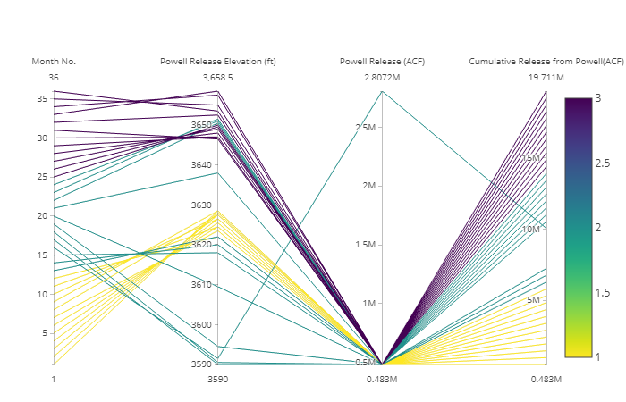

Figure 7 Results of the sub-model “Max” during maximizing the temperature objective at Lake Powell. The color scale is representing the years.

On the other hand, Figure 8 offers the results of the sub-model “Min” during minimizing the temperature objective at Lake Powell. Still, during the summer months the Lake elevation remain within the favorable elevation level window (between 3600 to 3675 ft). The model again become successful to meet the upper basin delivery target during one of the years and failed in remaining two. Interestingly, for this run, the model has selected year 1 to make huge releases and meet the upper basin delivery target instead of year 2. The expectation for the run was that model will be trying to empty the reservoir in order to go below the favorable storage level for temperature, which also means that more years meeting the upper basin delivery target. Nevertheless, the model just settled with local optimal solution.

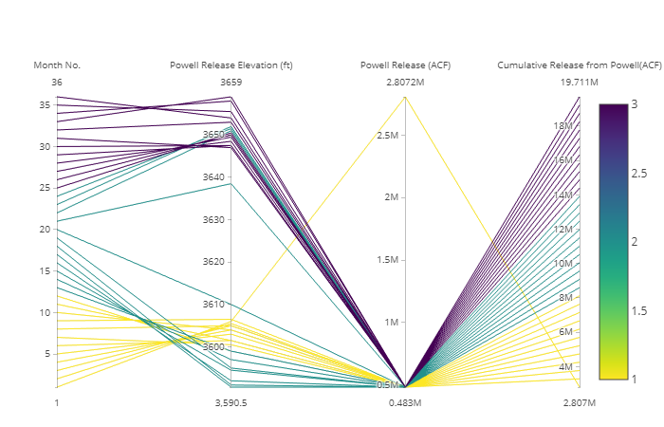

Figure 8 Results of the sub-model “Min” during minimizing the temperature objective at Lake Powell. The color scale is for the years.

Furthermore, Figure 9 are the results from the Max sub-model when the upper basin delivery objective was maximized and Figure 10 results from the Min sub-model when the upper basin delivery objective was minimized. It can be found in Figure 9 that model was just able to achieve the delivery target during year 1, whereas the results shown in figure 10 shows the model was not able to achieve the delivery target during any of the years (expected result because we are minimizing the objective). On the contrary if we look the corresponding temperature objective in Figure 9 and Figure 10, it can be concluded that Min sub-model with minimization of the upper basin delivery objective (Figure 10) is more suitable for the temperature objective at lake Powell.

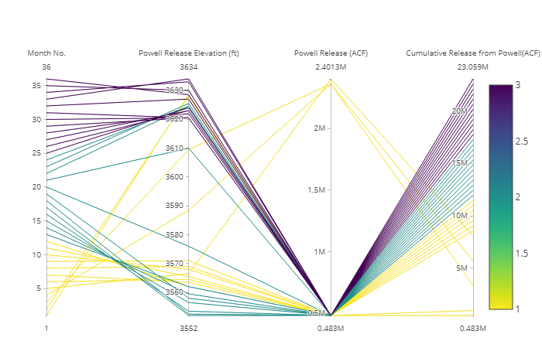

Figure 9 Results of the sub-model “Max” during maximizing the upper basin delivery objective at Lake Powell

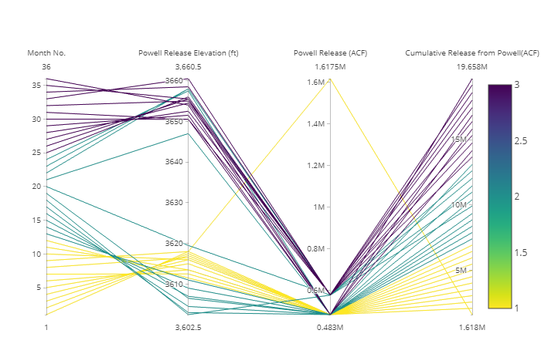

Figure 10 Results of the sub-model “Min” during minimizing the upper basin delivery objective at Lake Powell.

While looking at the results generated at Lake Mead during different model runs, it was found that was generating similar results for all the runs. We also checked the Model status of the runs to verify the working of the solver, and all the solutions were locally optimal. Which in other words mean we don’t have much to play with to improve the results of the solver. As an example, Figure 11 is showing the results from the Max sub-model run where Mead Elevation objective for Pearce ferry rapid was maximized.

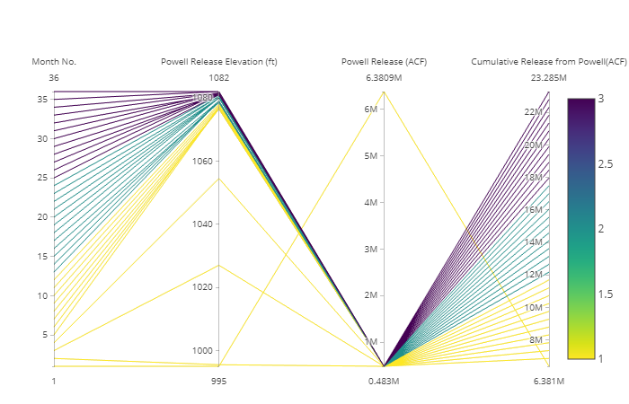Figure 11 Results of the sub-model “Max” during maximizing the Pearce Ferry Rapid Elevation objective at Lake Mead.

In Figure 11, it can be seen that all the months has storage elevation of less than 1135 ft. which means model achieved the Lake Mead elevation objective throughout the simulation period. However, the corresponding lower basin delivery target of 9 MAF/yr was only meet during year 1. The model releases almost 6 MAF during the first month of the simulation which can be possible in modeling world because the model is not violating the constraints, but almost impossible in the practical world dam operations.

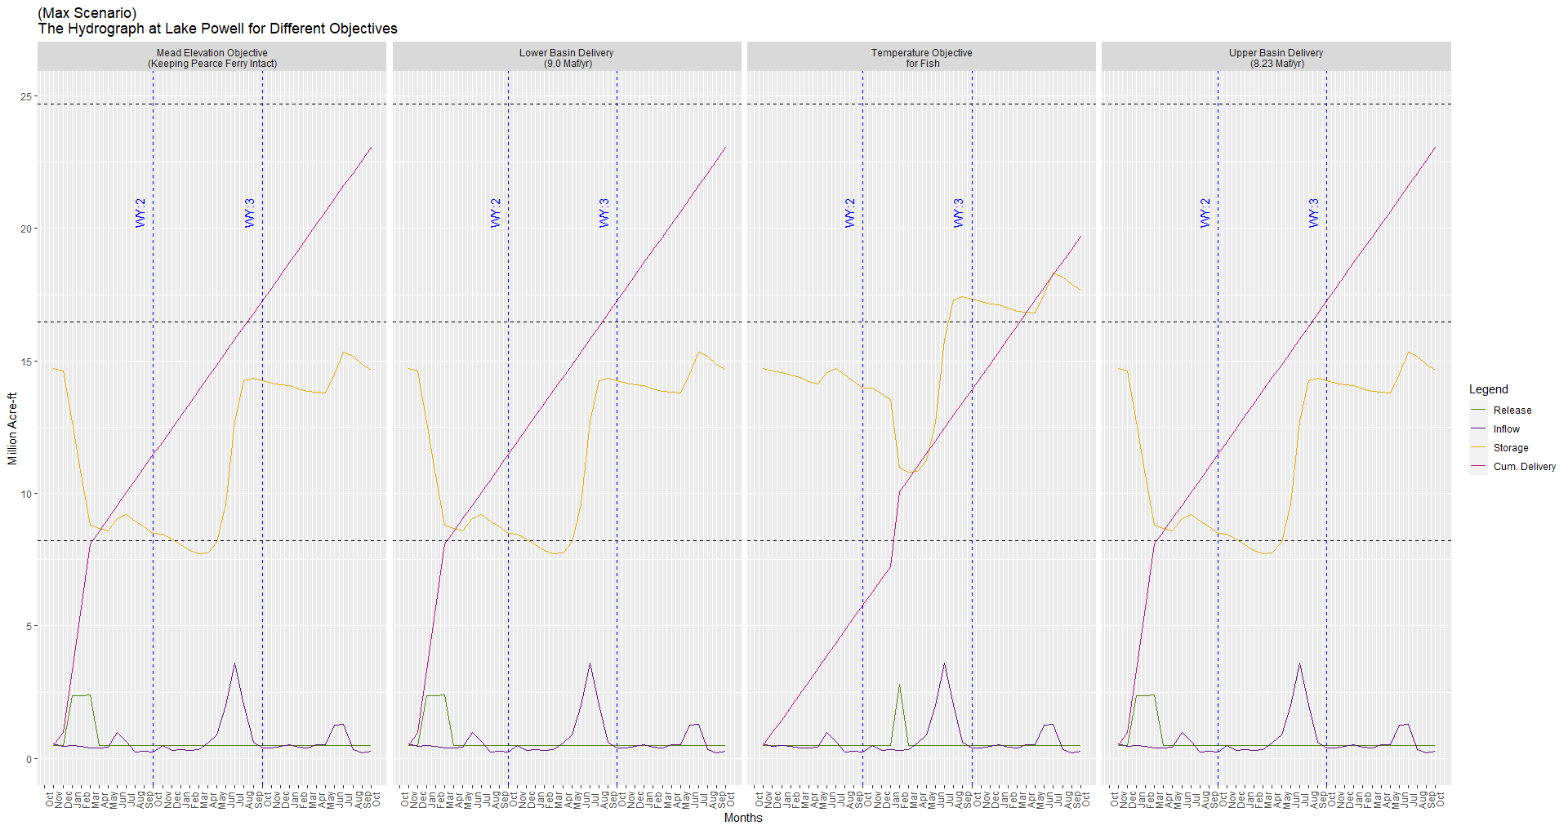Figure 12 presents the hydrograph generated at lake Powell during max sub-model for different objective. Here, the two right side panels are of most interest, because they provide release, storage, inflows, and cumulative delivery volume information of Lake Powell while considering the objectives of Lake Powell only. It can be noted that Powell overall meeting the upper basin total demand for three years (i.e. 24 MAF/ 3yrs) in the right most panel results and during temperature objective its total cumulative release volume was near to 20 MAF/ 3yrs.

Figure 12 The hydrograph at lake Powell for Max sub-model during different objectives.

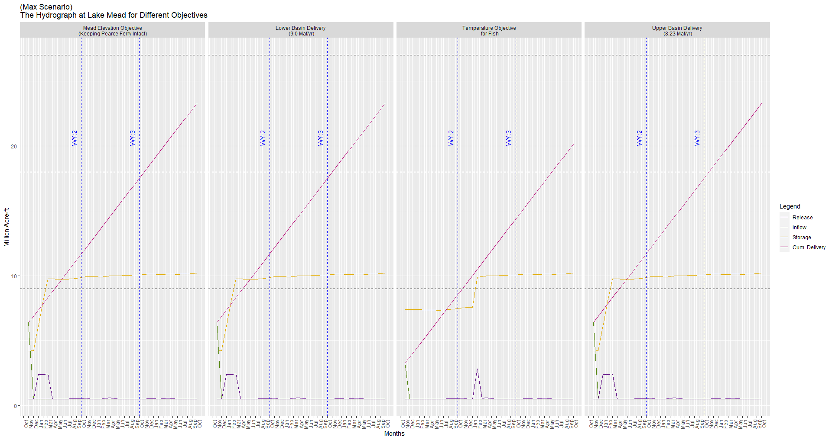While Figure 13 presents the hydrograph generated at lake Mead during max sub-model for different objective. Here, Model is producing similar results for most of the objectives except Temperature objective. The temperature objective was basically applied at Lake Powell and has no direct connection to decide the releases at Lake Mead. Hence, we can ignore that during Mead releases decision. Moreover, the results of the remaining sub-models can be found at the provided GitHub repository.

Figure 13 The hydrograph at lake Mead for Max sub-model during different objectives.

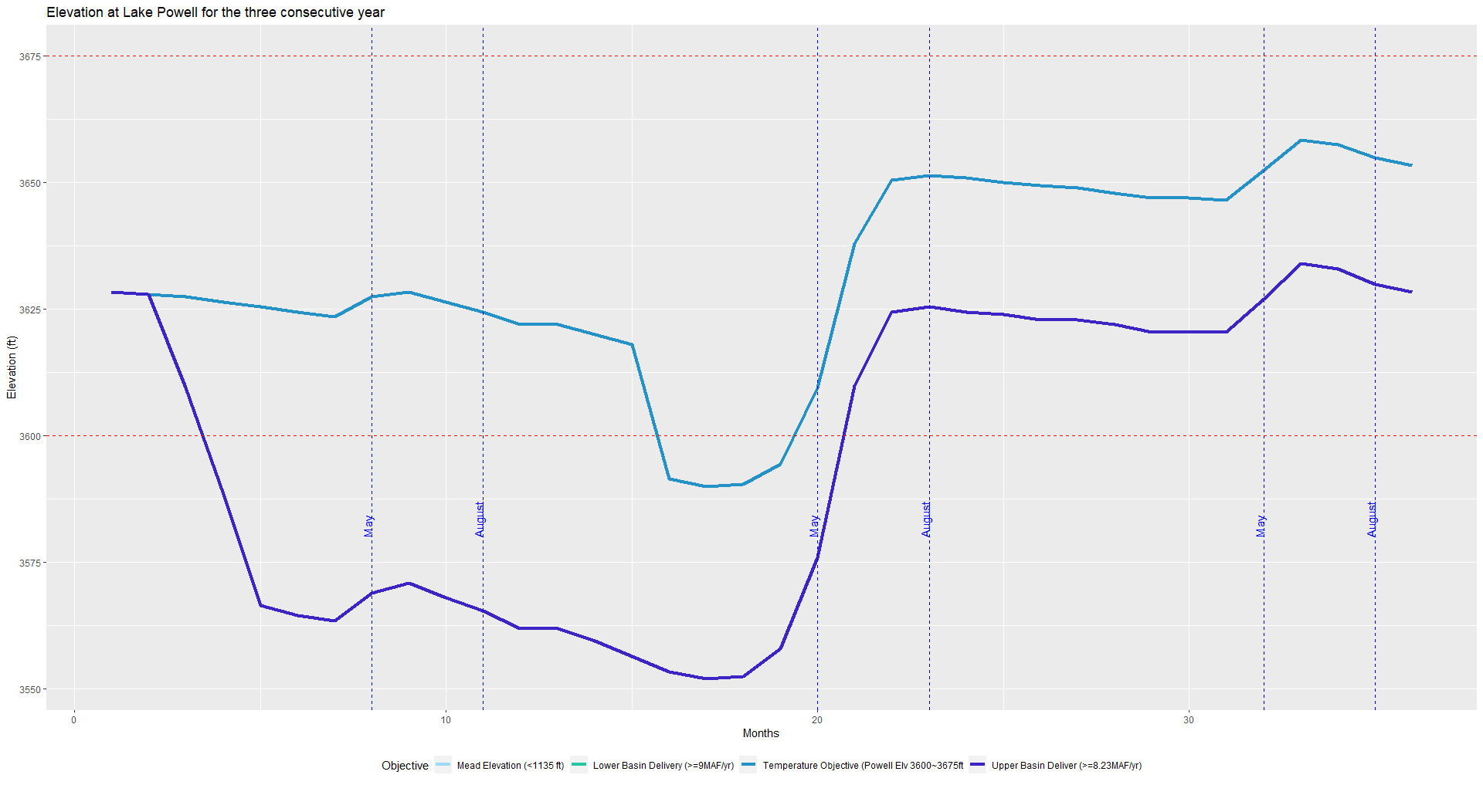Finally, Figures 14 and 15 are showing elevation changes over time at Lake Powell and Lake Mead, respectively. From Figure 14, it can be concluded that upper basin delivery objective and temperature objective doesn’t go together. Whereas, lower basin water supply and lake Mead elevation objectives seems achievable side by side (Figure 15).

Figure 14 Lake Powell elevation change overtime during different model runs

Figure 15 Lake Mead elevation change overtime during different model runs

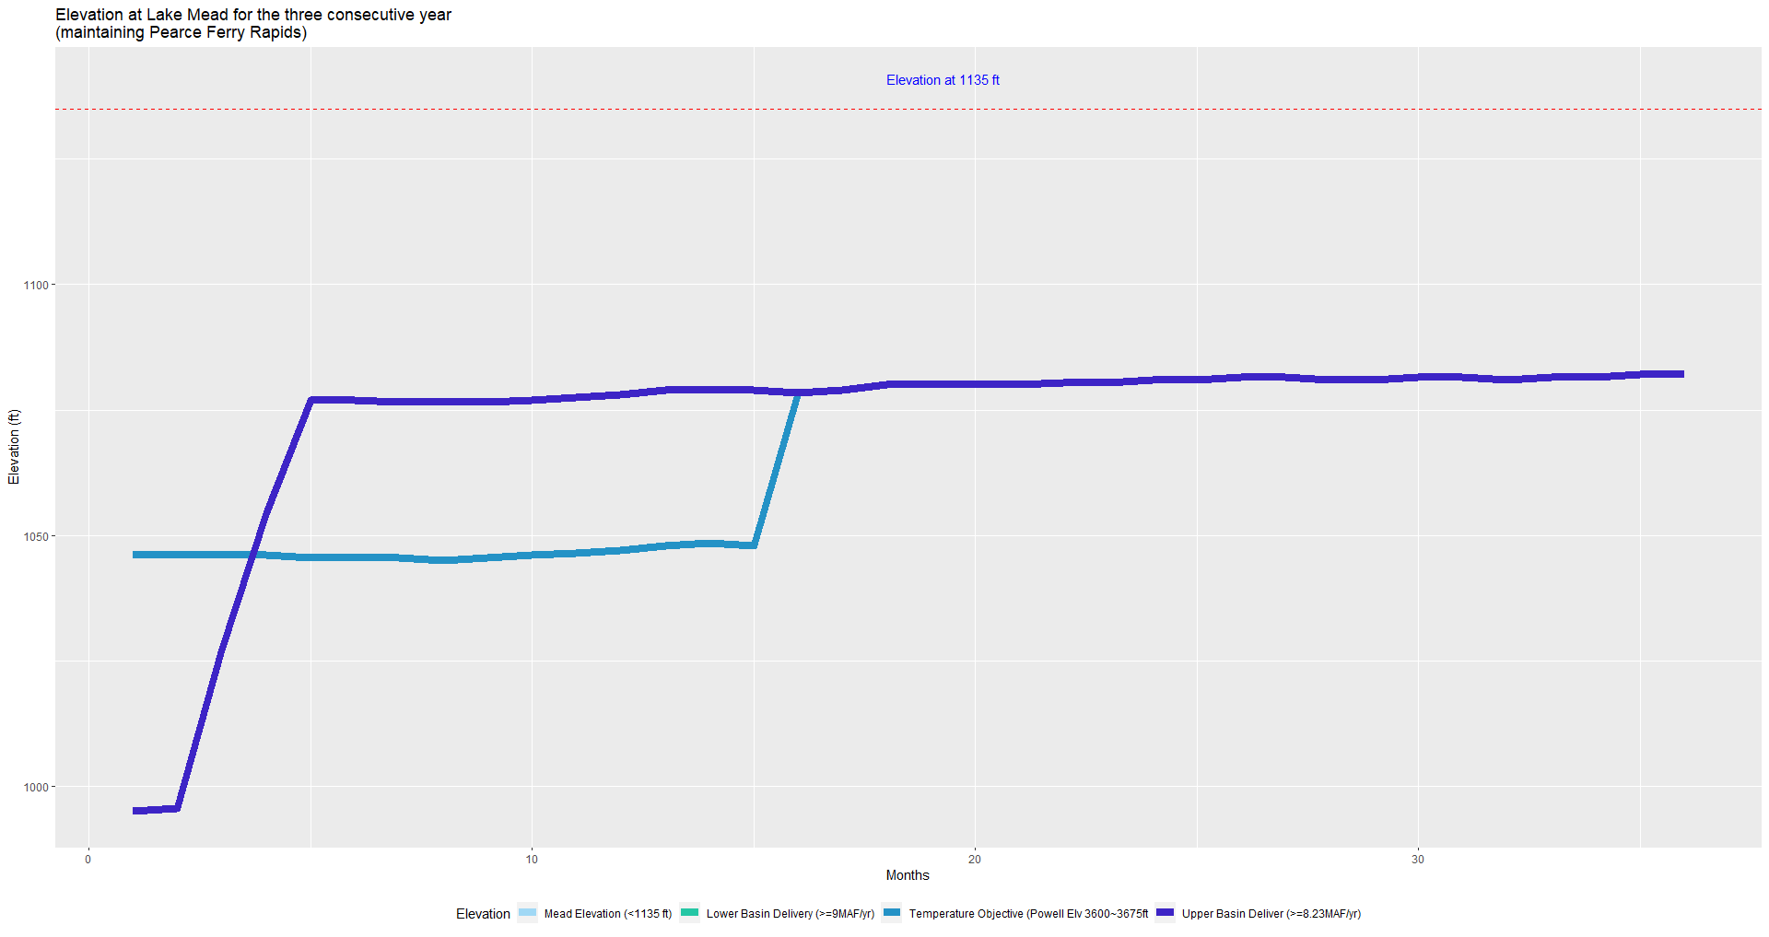

We also developed a 20-year model to test the application of the model over longer time period. However, that model till now is infeasible for most of the runs due to various reasons. One of the main reasons of infeasibility being lack of monthly and annual release volume constraints. Nevertheless, that model along with its input file can be found at the provided GitHub repository for future reference.

# **Future Modification**

# This study has not considered the "Intentionally Created Surplus" rules defined in the Interim Shortage Guideline. The rules state that the lower basin states can bank water in Lake Mead during the drought period, and deliveries will be restricted when the Mead elevation is dropped to 1,075 feet above MSL. Also, recently, the U.S. Congress has approved an agreement concerning the Colorado River Drought Contingency Management and Operations (DCP) that states that the deliveries will be reduced to the Central Arizona Project and the Southern Nevada Water Authority when Lake Mead elevation drops to 1,090 feet instead of 1,075 feet, and California will also share the shortages when the elevation depletes to 1,045 feet. These values can be used as constraints to define the rules and can be included in the current model's future modifications.

# **Conclusion**

During this study we successfully developed a non-linear multi-objective optimization model for coordinated reservoir operation of lake Powel and Lake Mead. We considered four objectives, two at each of the reservoirs. The focus of this study was to find the reservoir operations which can meet both water supply and ecosystem objectives.

The model results show that it is possible to achieve both water supply and ecosystems objectives over a short period of time (e.g. 3 years). These objectives over longer period (e.g. 20 years) competes against each other because of variable inflows, which ultimately leads us to find the tradeoffs between objectives. Although, the developed model was not able to achieve the global optimal solution due to number of reasons, still the local optimal solutions found by the model provides different valuable insights to improve the operations of the system. For example, Figure 14 shows that if the upper basin delivery objective is only maximized at Lake Powell that can be unfavorable for the ecosystem objective (Temp_Obj). Whereas, maximization of Temp_Obj can be benefical for both the upper basin delivery and ecosystem objectives.

Overall, the work presented here provides a tool which has good understanding of the system and can be easily modified in future for more practical applications. It should be noted that the results presented here are not global optimal solutions and are subjected to be improve if the solver performs better. The results from the valid sub-model attests this conclusion that current local optimal solutions from the solver are far from the global optimal solution. Hence, there exist plenty of room for improvement in future in term of debugging and extending the application of the model, in general.

# **References:**

Alminagorta, O., Rosenberg, D. E., & Kettenring, K. M. (2016). Systems modeling to improve

the hydro‐ecological performance of diked wetlands. Water Resources Research, 52(9), 7070-7085.

Bunch, A. J., Osterhoudt, R. J., Anderson, M. C., & Stewart, W. T. (2012). *Colorado River Fish Monitoring in Grand Canyon , Arizona — 2012 Annual Report*. (December), 1–41. <https://doi.org/10.13140/RG.2.2.31954.61124>

Colorado River Governance Initiative. (2012). Does the Upper Basin Have a Delivery Obligation

or an Obligation Not to Deplete the Flow of the Colorado River at Lee Ferry? <https://scholar.law.colorado.edu/cgi/viewcontent.cgi?article=1006&context=books_reports_studies>

Glen Canyon Dam Wikia, (2020), <https://gcdamp.com/index.php?title=TEMPERATURE>

Glen Canyon Dam Wikib, (2020), <http://gcdamp.com/index.php?title=File:LTEMP_monthly_volumes.png>

Gloss, S., Lovich, J., & Melis, T. (2005). *The State of the Colorado River Ecosystem in Grand Canyon: USGS Circular 1282*.

Kegerries, R. B., Albrecht, B., McKinstry, M. C., Rogers, R. J., Valdez, R. A., Barkalow, A. L., … Smith, E. O. (2020). Small-Bodied Fish Surveys Demonstrate Native Fish Dominance Over 300 Kilometers of the Colorado River Through Grand Canyon, Arizona. Western North American Naturalist, 80(2), 146. <https://doi.org/10.3398/064.080.0202>

Kennedy, T. A., Muehlbauer, J. D., Yackulic, C. B., Lytle, D. A., Miller, S. W., Dibble, K. L., & Baxter, C. V. (2016). Flow management for hydropower extirpates aquatic insects, undermining river food webs. BioScience, 66(7), 561-575.

MacDonnell, L. (2020). 2000-2019 in the Colorado River Basin and Beyond. *Available at SSRN 3638634*. <https://papers.ssrn.com/sol3/papers.cfm?abstract_id=3638634>

Mihalevich, B. A., Neilson, B. T., Buahin, C. A., Yackulic, C., & John, C. (n.d.). *Water temperature controls for regulated rivers in complex topographic regions*.

National Park Service (July 24, 2018), (<https://www.nps.gov/grca/learn/nature/fish-native.htm>)

Rice, J. Controlled Flooding in the Grand Canyon: Drifting Between Instrumental and Ecological Rationality in Water Management. Organization & Environment, 26(4), 412–430. https://doi.org/10.1177/1086026613509250 (2013).

Rogowski, D. L., Osterhoudt, R. J., Mohn, H. E., & Boyer, J. K. (2018). Humpback Chub (Gila cypha) Range Expansion in the Western Grand Canyon. Western North American Naturalist, 78(1), 26–38. <https://doi.org/10.3398/064.078.0105>

Rosenberg, D. (2020). Colorado River Fitures - Code Projects: How much water to store in Lake

Powell to benefit native fish of the Grand Canyon? Utah State University. Logan, Utah. https://github.com/dzeke/ColoradoRiverFutures/tree/master/LakePowellTemperatureScenarios

Schmidt JC, Webb RH, Valdez RA, Marzolf GR, Stevens LE. 1998. Science and values in river restoration in the Grand Canyon. BioScience 48:735–747.

U.S. Department of the Interior Bureau of Reclamation. (2000), “Colorado River interim surplus criteria: final environmental impact statement”. <http://www.usbr.gov/lc/region/g4000/surplus/SURPLUS_FEIS.html>

U.S. Department of the Interior Bureau of Reclamation. (2007), “Colorado River System Facilities and Current River System Operations from Lake Powell to SIB” <https://www.usbr.gov/lc/region/programs/strategies/FEIS/AppB.pdf>

United States Bureau of Reclamation <https://www.usbr.gov/lc/region/pao/pdfiles/crcompct.pdf>

United States Bureau of Reclamation <https://www.usbr.gov/lc/phoenix/AZ100/1940/mexican_water_treaty.html#:~:text=The%20Mexican%20Water%20Treaty%20of,Colorado%20River%20Compact%20of%201922>

U.S. Department of the Interior. (2016). *Record of decision for the Glen Canyon Dam long-term experimental and management plan final environmental impact statement*. 196.

U.S. Fish and Wildlife Service (<https://www.fws.gov/fisheries/freshwater-fish-of-america/humpback_chub.html#:~:text=The%20humpback%20chub%20reaches%20sexual,57.2%20%E2%80%90%2075.2%20degrees%20Fahrenheit>.)

U.S. Geological survey. <https://pubs.usgs.gov/fs/2011/3002/fs2011-3002.pdf>

Valdez, R. A., Speas, D. W., & Kubly, D. M. (2013). Benefits and risks of temperature modification at Glen Canyon Dam to aquatic resources of the Colorado River in the Grand Canyon. U.S. Bureau of Reclamation, Upper Colorado Region, Salt Lake City, UT, (September).

Voichick, N., & Wright, S. A. (2007). Water-temperature data for the Colorado River and tributaries between Glen Canyon Dam and Spencer Canyon, northern Arizona, 1988-2005 (p. 24). Washington, DC: US Geological Survey.

Williams, N. T. (2009). Projecting Temperature in Lake Powell and the Glen Canyon Dam Tailrace. 2008, 1–9. Retrieved from <https://www.researchgate.net/profile/Theodore_Melis/publication/258998603_Proceedings_of_the_Colorado_River_Basin_Science_and_Resource_Management_Symposium_November_1820_2008_Scottsdale_Arizona/links/00b7d529a09f5a86cb000000.pdf#page=165>

Wright, S. A., Anderson, C. R., & Voichick, N. (2009). A simplified water temperature model for the Colorado River below Glen Canyon Dam. *River Research and Applications*, *25*(6), 675–686. [https://doi.org/10.1002/rra.1179](https://doi.org/10.1002/rra.1179\)